
CONFIDENTIAL CS/NOV 2026/ICT450

UNIVERSITI TEKNOLOGI MARA FINAL EXAMINATION

COURSE
COURSE CODE
EXAMINATION TIME
DATABASE DESIGN AND DEVELOPMENT

ICT450
NOVEMBER 2026
3 HOURS

INSTRUCTIONS TO CANDIDATES

- This question paper consists of five (5) questions.

- Answer ALL questions in the Answer Booklet. Start each answer on a new page.

- Do not bring any material into the examination room unless permission is given by the invigilator .
- Please check to make sure that this examination pack consists of: i) the Question Paper
  - an Answer Booklet - provided by the Faculty

- Answer ALL questions in English.

DO NOT TURN THIS PAGE UNTIL YOU ARE TOLD TO DO SO

This examination paper consists of 6 printed pages.

QUESTION 1 (20 marks)
a) The file system method of organizing and managing data was a definite improvement over the manual system. Nonetheless, many problems and limitations become evident to this approach. Describe TWO (2) problems associated with a file system.
(4 marks)
Table : TRUCK
Truck_Num | Base_Code | Type_Code | Truck_Miles | Truck_Serial_Num
1001 | 501 | 1 | 5676.89 | AA-322-1222-W11
1002 | 502 | 1 | 12232.67 | AV-678-4545-Q23
1003 | 501 | 2 | 9886.68 | FR-456-1123-R45
1004 | 501 | 2 | 23445.76 | AD-213-7654-WQ
1005 | 502 | 3 | 454.98 | XV-987-1234-SQ
Table : BASE
Base_Code | Base_City | Base_State | Base_Postcode | Base_Manager
501 | Jasin | Malacca | 77000 | Fattah Aziz
502 | Shah Alam | Selangor | 40000 | Michael Faraday
503 | Kuala Kangsar | Perak | 33000 | Benjamin
Table : TYPE
Type_Code | Type_Description
1 | Single box, double-axie
2 | Single box, single axie
3 | Tandem trailer, single axie
b) The Entity Relationship (ER) Model introduced by Chen in 1976 is widely accepted and adapted graphical tool for data modeling. Describe the basic structure of ER Model and discuss TWO (2) advantages of having an ER Model in database management system.
(4 marks)
c) Given the following tables :
i) Describe the type(s) of relationship(s) between TRUCK and BASE relations. Identify the entity integrity (if any) for each table. Answer YES or NO, and then explain your answer.
(5 marks)
ii) Draw the ER Diagram that corresponds to the above tables. Include all the appropriate connectivity and cardinalities of the relationships.
(7 marks)
QUESTION 2 (20 marks)
a) A proper written business rules are used to define entities, attributes, relationships, and constraints. Careful derivation and definition of business rules are crucial to produce a good database design. Based on Figure 2.0, describe in the context of database design. the concept of entity and attribute. Give TWO (2) examples of entities and attributes in your description.
(8 marks)
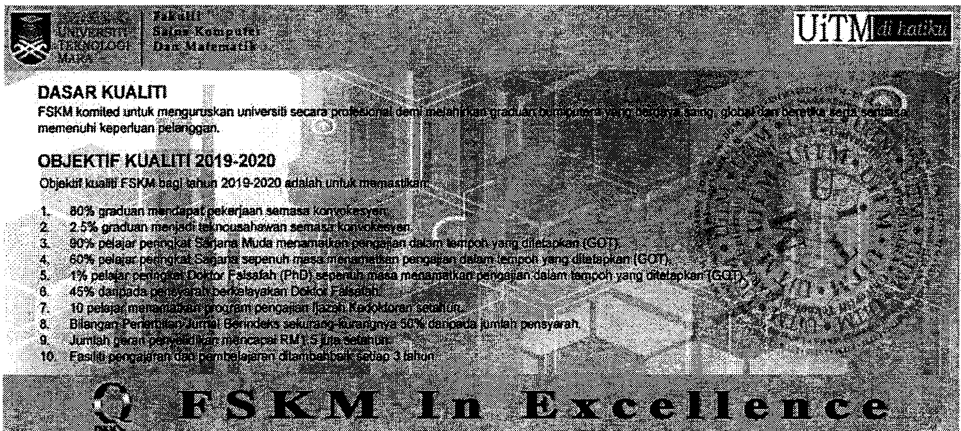
Figure 2.0 : FSKM Website
b) Indicate the purpose of having entity integrity in a relational database.
(2 marks)
c) In database design, there are two classical approaches which consists of Top-down and Bottom-up. Differentiate these approaches.
(4 marks)
d) Present THREE (3) types of periodic maintenance in DBMS.
(6 marks)
QUESTION 3 (20 marks)
The following questions are based on Figure 2.0.
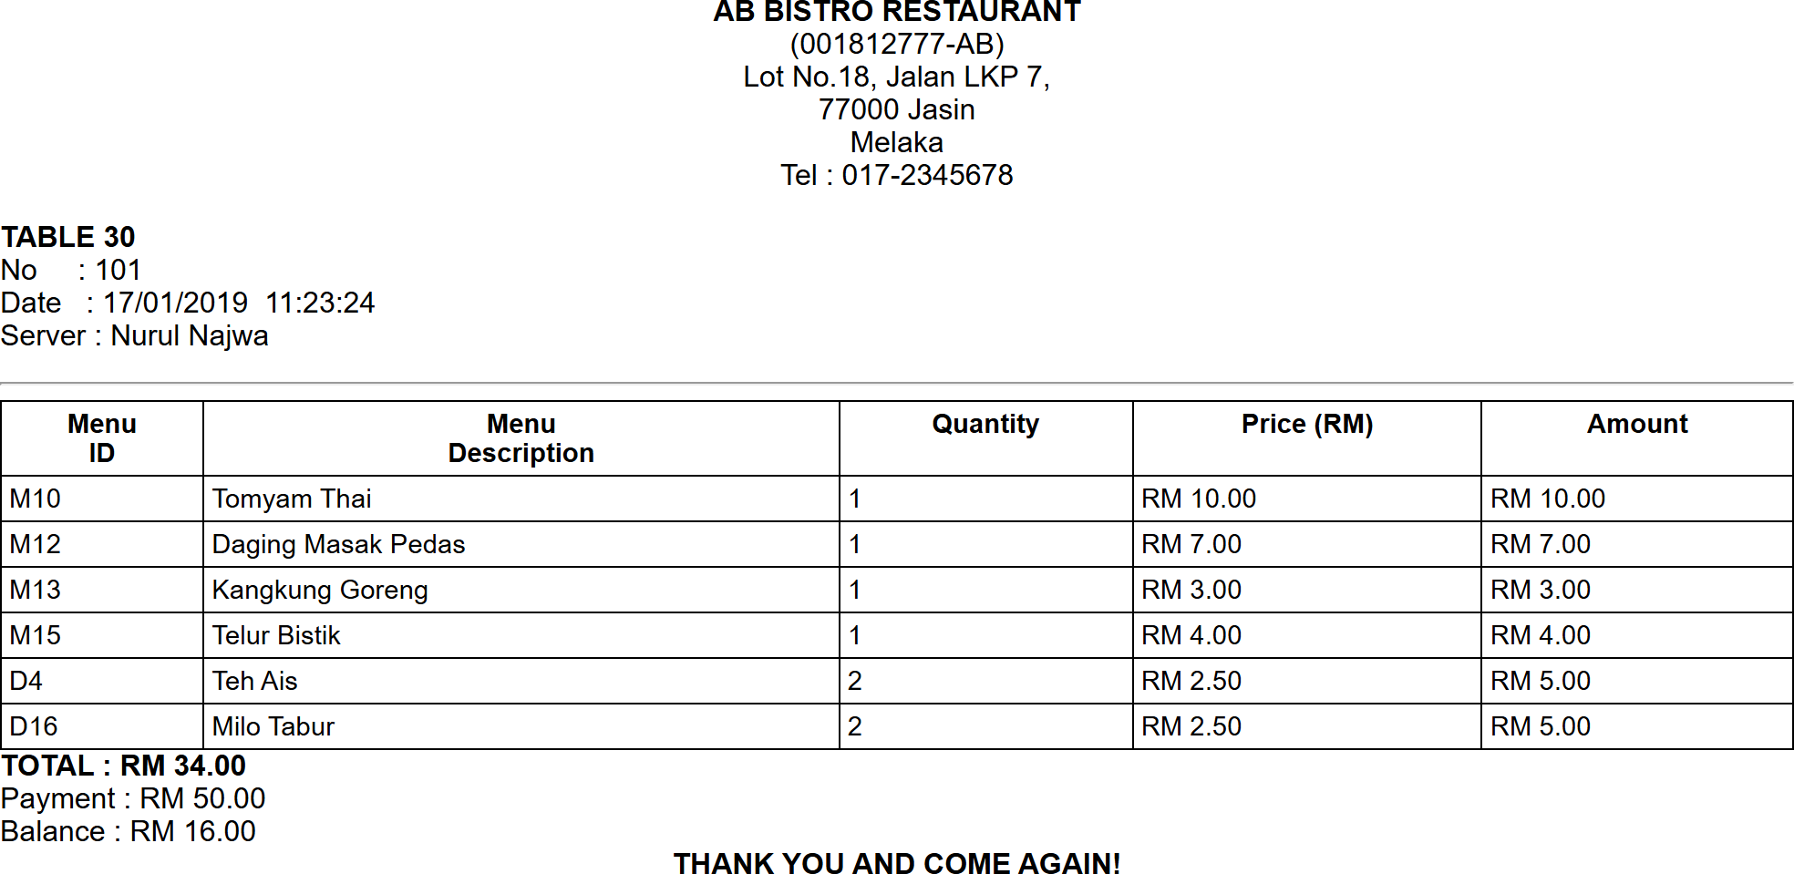
Figure 2.0 : AB Bistro Restaurant Receipt
a) State the normal form of the above receipt. Briefly explain your answer with reasons.
(3 marks)
b) Briefly explain the purpose of normalization in database design.
(3 marks)
c) Normalize Figure 2.0 above until third normal form (3NF). Show all your work for each normalization stage.
(14 marks)
QUESTION 4 (20 marks)
Consider the following relational database:
PUBLISHER (PublisherName, City, State, Country, PhoneNum)
AUTHOR (AuthorNum, AuthorName)
BOOK (ISBN, BookName, PublicationYear, AuthorNum, PublisherName)
CUSTOMER (CustNum, CustName, Street, City, State, Country, Email)
ORDER (OrderID, ISBN, CustNum, Date, Quantity)
a) Create table BOOK.
(4 marks)
b) Display the book number, book name and author name of all the books published by John Wiley & Sons Inc and Pustaka Berhad. View the results by book name in descending order.
(4 marks)
c) Find how many books that have been published in 2021 by Pustaka Trading located in Jasin, Melaka.
(4 marks)
d) Find the publisher which successfully published more than 50 books
(4 marks)
e) Find the book name which is total order is more than 3.
(4 marks)
QUESTION 5 (20 marks)
Chanteq Boutique is a local dress manufacturer. It sells its products to major distributors who distribute through their own stores in major cities and shopping malls. The primary product line is a casual dress for women.
Chanteq Boutique is in the process of designing a database system. The requirements needed are as following:
- Chanteq Boutique manufactures several products. Product id is a unique identifier. Product name is also need to be stored in this system.
- Each product has been assigned to a different stock-keeping unit (SKU). Each SKU belongs to a specific product. SKU number is a unique identifier of SKU. SKU description is also recorded in this table.
- Chanteq Boutique has created several unique colors for its dress. Each color is uniquely identified by a color id. A color description will describe the color options (e.g. red, blue, navy). Each SKU has only one color. Some colors have been assigned to SKU or may never be used.
- Each retailer will have a contract with Chanteq Boutique based on products it will distribute. A retailer will distribute one or more products, and a particular product will be distributed by more than one retailer. Each retailer has a unique id, name and phone number.
- Retailers have stores, which is the place where they sell the skirt and other products. Each retailer has one or more stores. To identify a store in the Chanteq Boutique database for shipping purposes, all customers have agreed to provide their store id and customer id as confirmation. They also need to write their address.
Based on the given information:
a) Construct an Entity Relationship Diagram (ERD) complete with all the required tables, attributes, relationships as well as the cardinalities using the Crow's Foot notation that reflects all of the given business rules.
(16 marks)
b) Briefly explain TWO (2) examples of reports that can be generated from ERD in (a).
(4 marks)

